Safeguarding Newsletter
Autumn Term 2023
Issue 1

Latest advice for parents and carers

Welcome to our new Safeguarding Newsletter.
Our aim is to bring you all the latest relevant help and advice on issues that we feel will be of importance to you and your family.
In this issue we want to introduce to you our Safeguarding Team, talk about the NSPCC campaign #ListenupSpeakup and share information on online safety for children.

 | Meet the Safeguarding Team
 |  | 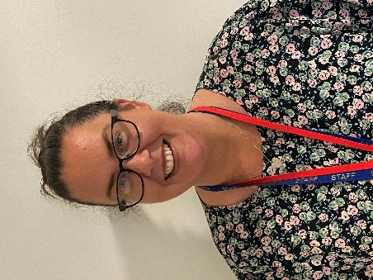 |  |  | 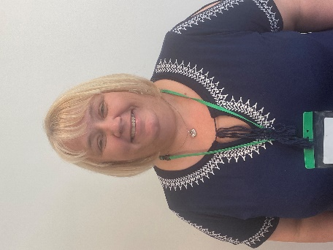
 | Mrs Bridges  Headteacher & Safeguarding Officer | Mrs Ritchie  Designated Safeguarding Lead | Mrs Major  Deputy Designated Safeguarding Lead |  | Mrs McFarlane  SENCO &  Safeguarding Officer
 | The safeguarding team oversee and co-ordinate all aspects of the school’s work to ensure that children are kept safe. They regularly attend training to ensure their skills and knowledge are up-to-date.
If you wish to speak to anyone in the safeguarding team or are worried about a child’s safety then please do not hesitate to contact them straight away. The team can be contacted via the school office on
0151 645 1561.
 | For further information of our school’s safeguarding ethos or for a copy of our school’s safeguarding policy please visit the safeguarding section of the school website.
Alternatively, if you are worried about a child’s safety you can also contact social services directly via the Integrated Front Door
0151 606 2008
Monday to Friday 9am – 5pm

Outside of these hours you can contact the Emergency Duty Team
0151 677 6557

If you feel that the situation is an emergency then dial
999
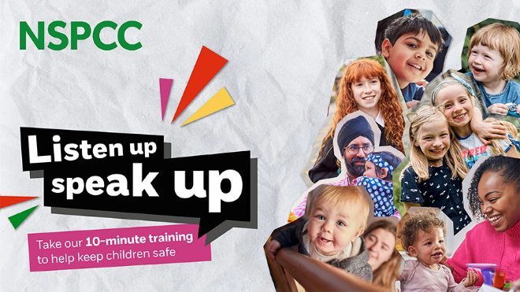 |  |  |  | Half a million children suffer abuse and neglect a year in the UK.  The NSPCC campaign Listen Up Speak Up (#ListenupSpeakup) is encouraging every adult in the UK to take their 10 minute digital training programme.  Their Connect the DOTS training shows you where to go if you need support and how to speak up for children who need it. Just a little bit of knowledge can help everyone to keep a lot of children safe.
https://www.nspcc.org.uk/support-us/listen-up-speak-up/
Online Safety
Online safety is something that we take very seriously at Bedford Drive. Children are spending more and more time online and it is important that they are taught the skills and knowledge to navigate the online world safely.
We are seeing a growing number of children using social media sites and being exposed to inappropriate and unsafe content on these sites. We would like to remind parents that most social media sites have an age restriction of 13+ years. This includes TikTok, Instagram, Snapchat, and Facebook.
There are many online risks for children using the Internet and apps. Some of these include:
Oversharing
Children can sometimes feel pressure to overshare online. Remind them that they shouldn’t share private things such as their personal information, which school they attend, photos of themselves and their body.
Sharing their location
Many apps and games give the user the option to share their location. You should help children think about how and when they are sharing it. If shared publicly their location could be seen by someone they don’t know.
Talking to people they don’t know
Some social networking sites promote connecting you to chat with people you don’t know. This puts children are risk of grooming or forms of online abuse.
Sending or receiving inappropriate content
Children can feel pressured into sharing content that could be harmful to themselves or others. This could be in the form of sexting or sharing nudes, or sharing images of others without their consent which could be a form of cyberbullying.
Unrealistic sense of body image or reality
With so many influencers and users sharing photos, children can feel under pressure to conform to the ‘ideal’ body and lifestyle. It’s important to talk to children about positive body image and help them see that what others post online may not be real.
Obsessive focus on likes and comments
Children may be very focused on how many likes or comments their posts get which can leave them feeling that they aren’t good enough, or not as popular as others. Try to help them remember that likes aren’t everything.

