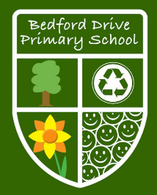

**As writers we will:**

* Write A Character Narrative
* Write A Newspaper
* Write A Cliffhanger Narrative
* Write An Instruction Manual
* Write A Suspense Narrative

**As part of spelling and grammar we will:**

* Use inverted commas, hyphens and commas for clarity.
* Use parenthesis, bullet points and colons.
* Use modal verbs, adverbs and relative clauses.
* Use pronouns.
* Use nouns and adjectives to create verbs using suffixes.
* Learn to spelling using the suffixes – pre, dis, mis.

**As mathematicians we will study:**

* Place value of digits up to 1,000,000
* Whole numbers addition and subtraction.
* Whole numbers multiplication and division
* Whole numbers word problems
* Graphs

At Bedford Drive Primary, children will be taught with a skills and knowledge based approach in order to deepen their understanding and develop a mastery approach to their learning. There may be times where topics are used to engage the children, but we will also be looking at relevant and current events in order to get the best learning from our children.

**Year 5**

**Autumn Term**

**Learning**

**As readers we will:**

* Apply our growing knowledge of root words, prefixes and suffixes (morphology and etymology), as listed in English Appendix 1, both to read aloud and to understand the meaning of new words that they meet.
* Read books that are structured in different ways and reading for a range of purposes.
* identify and discuss themes and conventions in and across a wide range of writing.
* Check that the book makes sense to us, discussing our understanding and exploring the meaning of words in context.
* Draw inferences such as inferring characters' feelings, thoughts and motives from our actions, and justifying inferences with evidence.

**As geographers we will**:

* Learn the known location of: capital cities of countries of British Isles and U.K., seas around U.K., European Union countries with high populations and large areas and the largest cities in each continent.
* Know how rivers erode, transport and deposit materials and know about the physical features of coasts and begin understand erosion and deposition.
* Understand and use a widening range of geographical terms e.g. specific topic vocabulary - climate zones, biomes and vegetation belts, rivers, mountains, volcanoes and earthquakes, and the water cycle.
* Understand about world weather patterns around the World and relate these climate zones.

**As musicians we will:**

* Play and perform in solo or ensemble contexts with some accuracy, control, fluency and expression.
* Sing as part of an ensemble with increasing confidence and precision.
* Improvise with increasing confidence using own voice, rhythms and varied pitch.
* Listen with attention to detail and recall sounds with increasing aural memory. Listen with attention to detail and recall sounds with increasing aural memory.

**As scientists we will study:**

**Animals including Humans**

* Describe the changes as humans develop to old age.

**Materials**

* Compare and group together everyday materials on the basis of their properties, including their hardness, solubility, transparency, conductivity (electrical and thermal), and response to magnets.
* Know that some materials will dissolve in liquid to form a solution, and describe how to recover a substance from a solution.
* Use knowledge of solids, liquids and gases to decide how mixtures might be separated, including through filtering, sieving and evaporating.

**Working Scientifically**

* Research the gestation periods of other animals and compare them with humans. Record the length and mass of a baby as it grows. (Compare with an adult for the same time period)- Sc 5 & 6
* Explore reversible changes, including evaporating, filtering, sieving, melting and dissolving – Sc 2, 3 & 4
* Explore changes that are difficult to reverse, for example, burning, rusting and other reactions, for example vinegar with bicarbonate of soda – Sc 1, 2, 3, 4, 5 & 6

**As historians we will:**

* Describe the achievements of the earliest civilisations of Ancient Egypt.
* Place current study on time line in relation to other studies known and sequence key events of time studied.
* Use relevant terms and periods.
* Present findings and communicate knowledge and understanding in different ways.
* Provide an account of a historial event based on more than one source.
* Begin to identify primary and secondary sources and use evidence to build up a picture of life in time studied.

**As sports persons we will:**

* Participate in team games.
* Play competitive games, modified where appropriate through team and individual games.
* Apply basic principles suitable for attacking and defending.
* Compete in a range of increasingly challenging situations.
* Children can follow a map in an unknown location.
* Children can use clues and compass directions to navigate a route.
* Children can change their route if there is a problem.

**In MFL we will speak in French:**

* Gain an overall understanding of an extended spoken text which includes some familiar language, for example summarising in English the key points of what he/she has heard in the target language.
* Take part in conversations and express simple opinions giving reasons.
* Use dictionaries to extend vocabulary on a given topic and develop his/her ability to use different strategies to work out the meaning of unfamiliar words.
* Create a short piece for presentation to an audience.
* Adapt known complex sentence to reflect variation in meaning.

**As artists we will:**

* Keep ideas in a sketchbook and try to reproduce using different media.
* Research and discuss various artists, architects and designers and discuss their processes and explain how these were used in the finished product.
* Discuss colours used by artists and develop a similar range of colours in own work.
* Look at how different artists use lines; experiment using some of their techniques.
* Look for patterns in the work of many different artists/cultures.
* Create patterns using the environment and other cultures as a stimulus to represent their feelings and ideas.
* Blend and shade using a variety of media.

O

**To promote SMSC we will:**

Spiritually- by reflecting on their own experiences, attending assemblies with an appreciation of different religious faiths and beliefs.

Morally- follow the Green rules of our school- understanding right from wrong and consequences, offer reasoned views about moral and ethical issues across the curriculum but most evident during RE, conscience alley role play and P4C lessons.

Culturally-show a range of positive social skills, celebrating different cultures in assemblies and lessons.

Socially- show a range of positive social skills, collaborate through discussions during lessons, participating in P4C debates, PE team games and role play activities. Appreciate, respect and celebrate the differences between every one.

Respect British Values by:

* Respecting individual liberty- taking turns, listening and valuing to the views of others as their right as a human during work and play times.
* Following the rule of law and forming our own Classroom Charter (based on the Unicef rights).
* Show mutual respect and tolerance of those with different faiths and beliefs in everything we do and supporting the global goals.

**As part of Religious Studies we will:**

* Show some understanding of different values and importance of worth in terms of what is ‘precious’ to them.
* Be aware of the importance/how precious of the Bible / Torah / Qur’an / Guru Granth Sahib etc. are for believers.
* Know and understand the importance for believers of feeling precious to God.
* Use some appropriate religious vocabulary related to Christmas.
* Show awareness of the significance of Christmas and characters involved.
* Understand the cause of celebration of the events of Christmas and their place in the Christian calendar.
* Show an awareness of the importance of belief in God, for the characters represented.
* Sequence the Christmas story.
* Use art to deepend their understanding of the Christmas Story.

**As designers we will:**

* Design and make a fabric advent calendar.
* Use his/her research into existing products and his/her market research to inform the design of his/her own innovative product.
* Learn about inventors, designers, engineers, chefs and manufacturers who have developed ground-breaking products.
* Create prototypes to show his/her ideas.
* Produce step by step plans to guide his/her making, demonstrating that he/she can apply his/her knowledge of different materials, tools and techniques.

**As computer whizzes we will:**

* Add formula to spreadsheets, enter data and use filters to sort information
* Add data validation e.g. drop-down lists and conditional formatting to spreadsheets.
* To be able to search the internet for specific information using tools such as Google Advanced Search (Boolean searches).
* To be able to skim read and sift information found online.
* To be able to check information for accuracy.
* To be able to identify irrelevant, biased, implausible and inappropriate information.
* Use “when and if ” commands to create responses.
* Use “say” commands to give information.
* To be able to upload informative and interesting content to a VLE including various media.
* To be able to initiate and take part in collaborative learning using a variety of methods e.g. email, discussions, quizzes, surveys, blogs, wikis, web quests, video conferencing.
* To be able to talk about how to use the social media and internet search engines safely.
* To be able to develop and understand rules for personal internet safety
* To be able to develop and understand code of conduct for online collaboration, and explain what to do in cases of cyberbullying.
* To be able to present findings to a specific audience

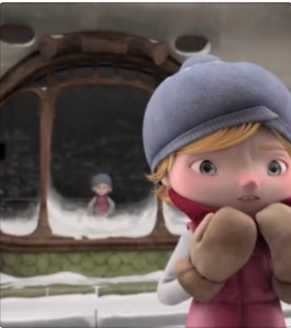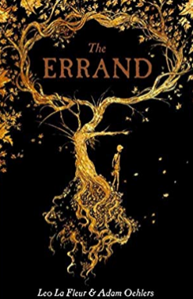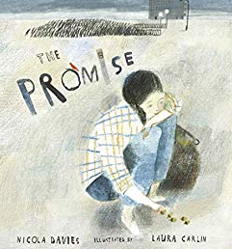j