**As mathematicians we will:**

Be counting to 10, counting objects to 10, writing to 10, counting to 0, comparing numbers of objects, ordering numbers, comparing numbers.

Making number bonds and making number stories.

Be adding by using number bonds, add by counting on, completing number sentences, making addition stories, solving picture problems

Subtract by crossing out, subtract by using number bonds, subtract by counting back, making subtraction stories, solving picture problems, addition and subtraction

Name positions, name positions in queues, naming left and right positions

Counting to 20, writing to 20, comparing numbers, ordering numbers, number patterns.

Add by counting on, add by making 10, add by adding ones, subtract by counting back, subtract by subtracting ones, subtract from 10, addition and subtraction facts

At Bedford Drive Primary, children will be taught with a skills based approach in order to deepen their understanding and develop a mastery approach to their learning. There may be times where topics are used to engage the children, but we will also be looking at relevant and current events in order to get the best learning from our children.

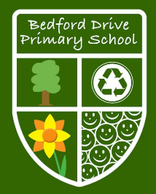

**As writers we will:**

Write clearly demarcated sentences.

Use ‘and’ to join ideas.

Use conjunctions to join sentences (e.g. so, but).

Use standard forms of verbs, e.g. go/went.

To be able to use but and so in a sentence spoken verbally

Introduce use of: capital letters, full stops, question marks &

exclamation marks

Use capital letters for names & personal pronoun ‘I’.

Letter, capital letter word, singular, plural sentence, punctuation, full stop, question mark, exclamation mark.

Names of the alphabet in order

**Year 1**

**Autumn Term Skills**

**As readers we will:**

To apply phonic knowledge and skills as the route to decode words

To respond speedily with the correct sound to graphemes (letters or groups of letters) for all 40+ phonemes, including, where applicable, alternative sounds for graphemes

To read accurately by blending sounds in unfamiliar words containing GPCs that have been taught

To read common exception words, noting unusual correspondences between spelling and sound and where these occur in the word

To read other words of more than one syllable that contain taught GPCs

To read books aloud, accurately, that are consistent with their developing phonic knowledge and that do not require them to use other strategies to work out words

To reread these books to build up their fluency and confidence in word reading

**As scientists we will:**

**Animals including Humans-**

Identify and name a variety of common animals including fish, amphibians, reptiles, birds and mammals.

Identify and name a variety of common animals that are carnivores, herbivores and omnivores.

Describe and compare the structure of a variety of common animals

(fish, amphibians, reptiles, birds and mammals, including pets)

Identify, name, draw and label the basic parts of the human body and say which part of the body is associated with each sense.

**Seasonal change**

Observe changes across the four seasons.

Observe and describe weather associated with the seasons and how day length varies.

**Plants**

Identify and name a variety of common wild and garden plants, including deciduous and evergreen trees

**As computer whizzes we will:**

To be able to tell an adult if they feel something they see online is inappropriate or hurtful.

Be able to use basic symbols to record directional instruction.

Be able to program a bot by giving single commands with an immediate outcome.

Be able to use the appropriate keys or commands to make a virtual or floor robot go forward, backward, left and right.

Be able to use basic symbols to record directional instruction.

Be able to use a developing range of language and styles of control e.g. tilt and turn/instructional to direct a robot.

**As geographers we will:**

Ask simple geographical questions

What is it like to live in a place like this?

To name the UK countries and their capital cities

Understand how some places are linked to other places e.g. roads, trains.

Recognise how places have become the way they are e.g. shops (patterns & processes

Describe seasonal weather changes.

Use locational and directional language (e.g. near and far; left and right) to describe the location of features and routes

Use simple observational skills to study the geography of the school and its grounds.

Make simple maps and plans e.g. pictorial place in a story.

Name, describe and compare familiar places.

**As historians we will:**

Sequence events or objects in chronological order

Sequence events and recount changes within living memory

Understand key features of events.

Identify some similarities and difference between ways of life in different periods.

**As designers we will:**

Begin to create simple designs for a product.

Use pictures and words to describe what he/she wants to do.

Select from and use a range of tools and equipment to perform practical tasks e.g cutting, shaping, joining and finishing.

Ask simple questions about existing products and those that he/she has made

Talk about what he/she eats at home and begin to discuss what healthy foods are.

Say where some foods come from and give examples of food that is grown.

Use simple tools with help, to prepare food safely.

**As artists we will:**

Explore patterns in everyday life

Trace natural patterns with finger

Explore surfaces and describe their feel

Make collage picture containing a variety of textiles

Name primary colours and sort materials into groups

Find colours in the environment

Explain what he/she likes about the work of others

**As sports people we will:**

Can show a good awareness of others in running, chasing and avoiding game.

Can make simple decisions about when and where to run.

**As musicians we will:**

Learn and perform chants, rhythms, raps and songs.

Work and perform together with others as an ensemble or as a group singing.

Listen to, copy and repeat a simple rhythm or melody.

Understand that tempo describes how fast or slow the music is.

Listen to music with sustained concentration.

Discuss feelings and emotions linked to different pieces of music.

**Stimulus we will use to engage our learners:**

**The Literacy Shed- Bubbles The Leaf Man The Queen’s Hat**

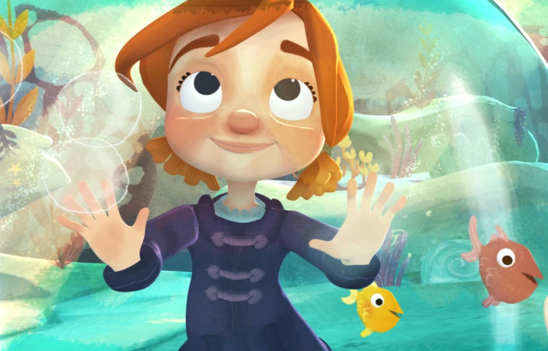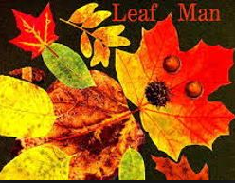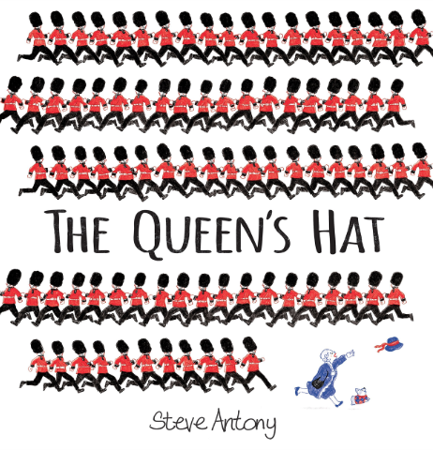

**To promote SMSC we will:**

Know right from wrong

Co-operates and works well as a team

Are open to new ideas and beliefs

Understands their own cultures and beliefs and what shapes them.

knows what makes them and others happy.

Make connections

Shows empathy

Confidently upholds their values and principles

**In RE we will learn:**

**Harvest/Helping hands-** about poems, to show how hands can convey / communicate what we are doing and how we are, feeling. To show sensitivity to the needs of others. To show an increased knowledge of people who help us, to show developing listening skills. Children will know that Jesus used his hands to bless others and that Christians do the same now. Through this work, children develop a greater awareness of God’s care for us all at all times. Children show a growing awareness of the importance of serving others, and that by using their hands, they are using their talents. Children begin to show empathy with the disabled.

**Christmas-** To know that we all have special times we remember, celebrations are similar but are different to ordinary days, to know there are different reasons for holding celebrations, to begin to show an appreciation that a special event takes a lot of preparation, to identify artefacts associated with specific celebrations, to recognise that a baptism is a religious event/ celebration, to know that Advent is a preparation time for the Christian festival of Christmas, to show an increasing knowledge of how the festival is celebrated, to know who key people in the story are, to know that the birth of Jesus can be found in the New Testament, to recount, re-tell, re-enact the story in its correct sequence.