Year 1 Curriculum Map 2022/23
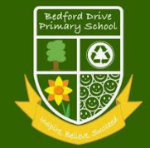 | Whole School Connector:  ‘A Moment in Time’  (History & Music) |  |  |  |  | Whole School Connector:  ‘Adrift’  (PSHE / Values / UNICEF)  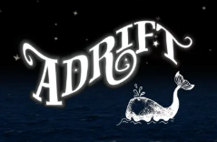 |  |  |  |  |  |  |  |  |  | Whole School Connector:  ‘The Way Things Work’  (Science, DT, Computing) |  |  |  |  |  |  | Whole School Connector:  ‘Think Global’  (Geography & Art)
 | Thrive Model: Self |  |  |  |  | Thrive Model: Society |  |  |  |  |  |  |  |  |  |  |  |  |  |  |  |  | Thrive Model: Global
English  (Literacy Counts Units of Work) | 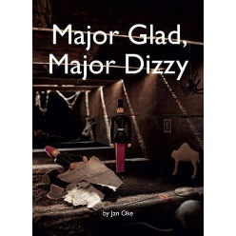 | 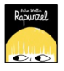 |  |  |  | 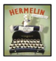 |  |  |  |  | 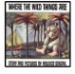 |  |  |  |  | 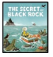 |  |  |  |  |  |  | 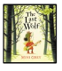
 | Finding Story  Recount Messages | Traditional Tale  Instructions |  |  |  | Detective Story  Letters |  |  |  |  | Portal Story  N/C Report |  |  |  |  | Return Story  Postcards |  |  |  |  |  |  | Hunting Story  Recipes
Steps to Read | Everyday Materials | Identifying  Animals |  |  |  | My Body |  |  |  |  | Identifying  Plants |  |  |  |  | Seasonal Changes  Identifying  Animals(recap) |  |  |  |  |  |  | Consolidation of prior learning through SC1- Working Scientifically
Class Novels | 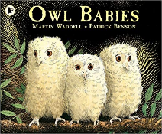  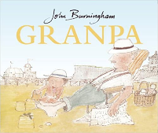  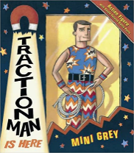 |  |  |  |  |  |  |  |  | 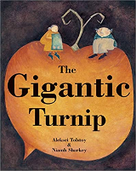  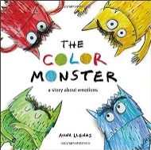  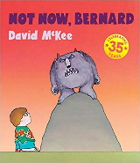 |  |  |  |  |  |  |  |  |  |  |  | 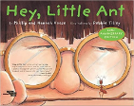  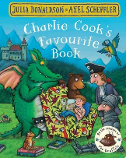  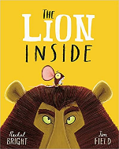
Maths | See ‘Maths No Problem’ overviews for more information
Science | Everyday Materials |  |  | Identifying  Animals |  |  |  | My Body |  |  |  |  |  |  | Identifying  Plants |  |  |  |  |  | Seasonal Changes  Identifying  Animals(recap) |  |  |  |  | Consolidation of prior learning through SC1- Working Scientifically
History | History of communication |  |  |  |  |  |  |  |  |  |  |  |  |  |  | History of transport |  |  |  |  |  |  | 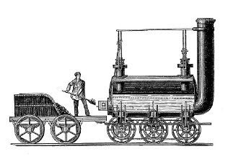
Geography | 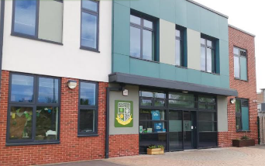 |  |  | Where we live, Rock Ferry/Wirral |  |  |  | 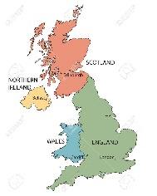 |  |  |  |  |  |  | Continents of the World(and animals that live there |  |  |  |  |  |  |  |  |  |  | The Four Seasons
Music  Charanga Units of Work | Autumn 1:  Unit: Hey You!  Style: Old-School Hip Hop |  | Autumn 2:  Unit: Rhythm in The Way We Walk and Banana Rap  Style: Reggae, Hip Hop  Christmas Songs |  |  |  |  |  | Spring 1:  Unit: In The Groove  Style: Blues, Latin, Folk, Funk, Baroque, Bhangra |  |  |  |  | Spring 2:  Unit: Round and Round  Style: Latin Bossa Nova, Film music, Big Band Jazz, Mash-up, Latin fusion |  |  |  |  | Summer 1:  Unit: Your Imagination  Style: Pop |  |  |  |  | Summer 2:  Unit: Reflect, Rewind and Replay  Style: Western Classical Music
Art | This is Me! (photography and mixed media)  Self-Portraits  Children will learn about portraits. They will develop their drawing techniques and to draw their own self-portraits. They will use photography and mixed media to create portraits in the style of Andy Warhol |  | 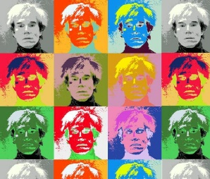 |  |  |  | Plants – Sculpture / Printing  Children will learn about different kinds of nature sculptures and explore the work of Andy Goldsworthy. Leaves and clay sculpture. |  |  |  |  | 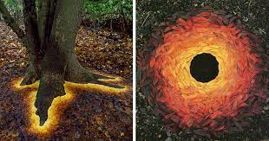 |  |  |  |  |  |  |  | Under the water - Textiles  Children will learn all about textiles techniques, they will focus on weaving and will make their final piece using this technique. They will weave paper and other materials to create under the sea scenes, inspired by crafts people around the world, in particular, Gunta Stolzl. |  |  |  |  |  |  | 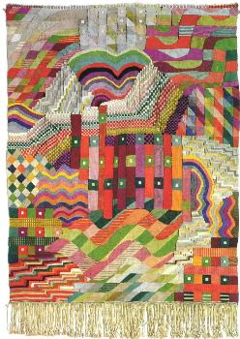
DT |  |  | Structures  Freestanding structures  (Tower for Rapunzel) |  |  |  |  | 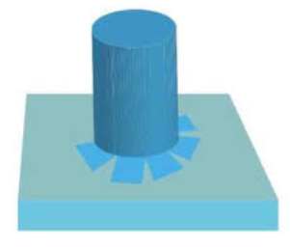 |  |  |  |  | Mechanisms  Sliders and levers  (moving pictures) |  |  |  |  | 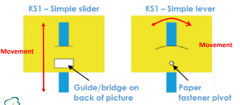 |  |  |  |  |  |  | Cooking and Nutrition  Preparing fruit and vegetables  (Fruit smoothie)
Computing | Computing systems and networks – Technology around us |  | Creating media- digital painting |  |  |  |  |  | Creating media- digital writing |  |  |  |  | Data and information  Grouping  data |  |  |  |  | Programme A  Moving a robot |  |  |  |  | Programme B - Introduction to Animation
RE | Key Question: Does God want Christians to look after the world?  Religion: Christianity |  |  |  | Key Question: What gifts might Christians In my town have given Jesus if he had been born here rather than in Bethlehem?  Religion: Christianity |  |  |  |  | Key Question: Was it always easy for Jesus to show friendship?  Religion: Christianity |  |  |  |  |  |  | Key Question: Why was Jesus welcomed like a king or celebrity by the crowds on Palm Sunday?  Religion: Christianity |  |  |  |  | Key Question: Is Shabbat important to Jewish children?  Religion: Judaism |  |  |  |  |  | Key Question: Are Rosh Hashanah and Yom Kippur important to Jewish children?  Religion: Judaism
PHSE  Jigsaw | Unit 1:  Being Me in My World |  |  |  | Unit 2:  Celebrating Difference |  |  |  |  | Unit 3:  Dreams & Goals |  |  |  |  |  |  | Unit 4:  Healthy Me |  |  |  |  | Unit 5:  Relationships |  |  |  |  |  | Unit 6:  Changing Me
PE | Unit 1 Attack Defend, Shoot,Hit, Catch, Run |  | Unit 1 Attack, Defend, Shoot |  |  |  |  |  | Unit 1 Gymnastics  Unit 1 Send & Return |  |  |  |  | Unit 1 Dance Unit 2 Send & Return |  |  |  |  | Unit 2 Hit, Catch, Run OAA |  |  |  |  | Unit 1 Run, Jump, Throw  Unit 2 Run, Jump, Throw

Follow us on Twitter for regular updates and information @bedfordyr_1ks1

