**As mathematicians we will:**

Count, read and write numbers to 100. Counting forwards and backwards, starting on any number.

Read and write words of numbers 0- 20.

Be able to make ½ and ¼ of a shape, object and number.

Share and group objects

Tell the time to the hour and half past

Recognise coins and notes.

Count in multiples of 2s, 5s, and 10s.

Represent and use number bonds to 20.

At Bedford Drive Primary, children will be taught with a knowledge and skills based approach in order to deepen their understanding and develop a mastery approach to their learning. There may be times where topics are used to engage the children, but we will also be looking at relevant and current events in order to get the best learning from our children.

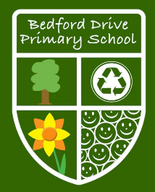

**As writers we will:**

Use ‘and’ to join ideas.

Use conjunctions to join sentences (e.g. so, but).

Use standard forms of verbs, e.g. go/went.

Use capital letters, full stops, question marks & exclamation marks

Use capital letters for names & personal pronoun ‘I’.

Name the letters of the alphabet in order.

Use –ing, -er, -est, -ed to change the meaning

Begin to form pre cursive letters

**Year 1**

**Spring Term Learning**

**As readers we will:**

To respond speedily with the correct sound to graphemes (letters or groups of letters) for all 40+ phonemes, including, where applicable, alternative sounds for graphemes

To read accurately by blending sounds in unfamiliar words containing GPCs that have been taught

To read common exception words, noting unusual correspondences between spelling and sound and where these occur in the word

To read books aloud, accurately, that are consistent with their developing phonic knowledge and that do not require them to use other strategies to work out words

To reread these books to build up their fluency and confidence in word reading

To become familiar with fairy stories and traditional tales, retelling them and considering their particular characteristics.

**As scientists we will:**

Observe changes across the four seasons.

Observe and describe weather associated with the seasons and how day length varies.

Distinguish between an object and the material from which it is made.

Identify and name a variety of everyday materials, including wood, plastic, glass, metal, water, and rock describe the simple physical properties of a variety of everyday materials.

Compare and group together a variety of everyday materials on the basis of their simple physical properties.

**As computer whizzes we will:**

Be involved in the process of transferring files from one device to another.

Be able to save and retrieve work, with support.

To be able to say what information is personal and should not be shared online with support.

Be able to use a graph presented on screen to answer questions.

Produce text on screen and make changes to make it clear.

**As historians we will:**

1. To describe simple similarities and differences between artefacts
2. To ask and answer questions related to different sources and objects
3. Talk, draw or write about aspects of the past.
4. Sequence events or objects in chronological

order

1. The lives of significant individuals in the past who have contributed to national and international achievements.

**As geographers we will:**

1. Ask simple geographical questions. What is it like to live in a place like this?
2. Use simple maps of the local area e.g. large scale, pictorial etc.
3. Understand how some places are linked to other places e.g. roads, trains.
4. Make simple maps and plans e.g. pictorial place in a story.

Describe seasonal weather changes.

**As designers we will:**

Begin to create simple designs for a product.

Use pictures and words to describe what he/she wants to do.

Build structures, exploring how they can be made stronger, stiffer and more stable.

Use leavers and sliders in a product.

Talk about what he/she eats at home and begin to discuss what healthy foods are.

Say where some foods come from and give examples of food that is grown.

Use simple tools with help, to prepare food safely.

**As artists we will:**

Collect 3-D shapes (boxes etc) and arrange in a variety of ways

Experiment with waste materials and try different ways of joining them

Explain what he/she likes about the work of others.

Collect and explore materials in tones of one colour.

**As sports people we will:**

Copy dance moves.

Make up a short dance.

Dance imaginatively.

**As musicians we will:**

Listen to, copy and repeat a simple rhythm or melody.

Understand that pitch describes how high or low sounds are.

Understand that tempo describes how fast or slow the music is.

Understand that dynamics describe how loud or quiet the music is.

Recognise different instruments.

Discuss feelings and emotions linked to different pieces of music.

**Stimulus we will use to engage our learners:**

**The Secret of Black Rock Hermelin Rapunzel**

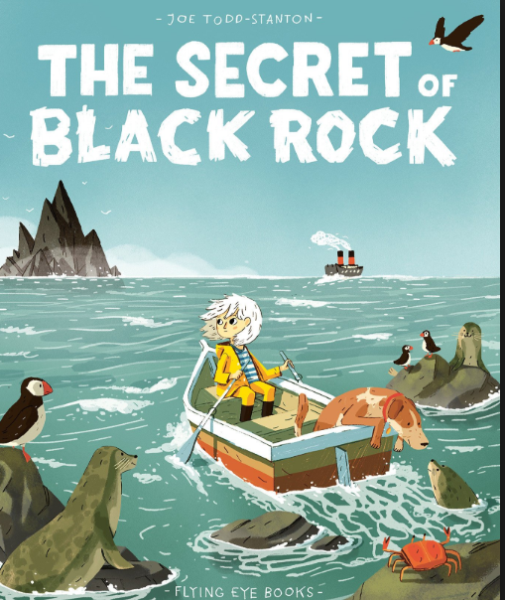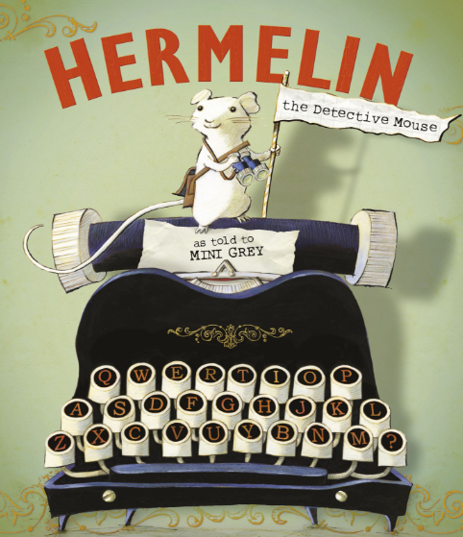 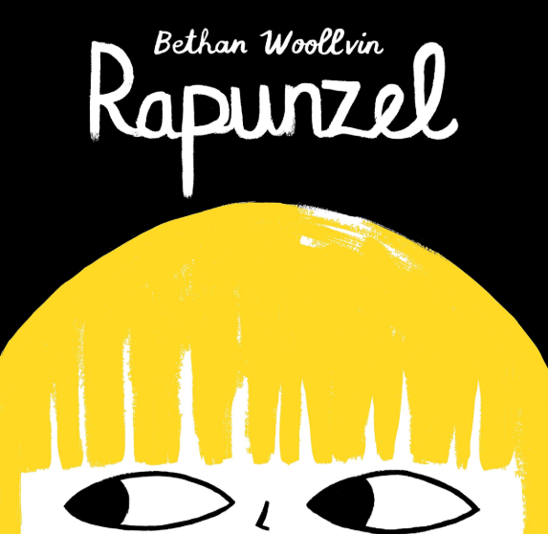

**To promote SMSC we will:**

Know right from wrong

Co-operates and works well as a team

Are open to new ideas and beliefs

Understands their own cultures and beliefs and what shapes them.

knows what makes them and others happy.

Make connections

Shows empathy

Confidently upholds their values and principles

**In RE we will learn:**

New Beginnings

Why do people around the world celebrate the start of a new year?

Compare their own to Chinese New Year.

Be able to recall the story of Chinese New Year.

Pupils talk about their own experiences/feelings.

Recognise cultural symbols related to Chinese New Year

Use simple everyday religious terms to describe New Year celebrations.

Recall The Story of Chinese New Year.

Easter

Talk about what makes a friend and what can break a friendship in simple terms.

Talk about who Jesus is.

Be able to retell the Easter Story in different ways.

Begin to understand the importance of the events to Christians and how they are a main Christian event.

Begin to understand when the events took place in time.