**As writers we will:**

* Use expanded noun phrases to add description & specification.
* Write with correct and consistent use of capital letters and full stops.
* Write a sequence of sentences to form a short narrative.
* Speaking and listening.
* Write different kinds of sentence: statement, and question.
* Write using subordination (because) and co-ordination (and, but).

At Bedford Drive Primary, children will be taught with a skills based approach in order to deepen their understanding and develop a mastery approach to their learning. There may be times where topics are used to engage the children, but we will also be looking at relevant and current events in order to get the best learning from our children.

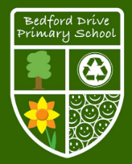

**As mathematicians we will:**

* Numbers to 100
* Addition and Subtraction
* Multiplication of 2, 5 and 10
* Multiplication and Division of 2, 5 and 10
* Length
* Mass
* Temperature
* Picture Graphs

**Year 2**

**Autumn Term Skills**

**As readers we will:**

* Draw on knowledge of vocabulary to understand texts
* Identify / explain key aspects of fiction and non-fiction texts, such as characters, events, titles and information
* Identify and explain the sequence of events in texts
* Make inferences from the text
* Predict what might happen on the basis of what has been read so far

**As computer whizzes we will:**

* Be able to predict a sequence of instructions
* Be able to program a bot to follow a pre-planned sequence by giving single commands with an immediate outcome.
* Be able to find a website by following links set up by the teacher
* Add and edit text, considering style, colour and layout of font

**As scientists we will:**

**Living Things and their Habitats**

* Identify that most living things live in habitats to which they are suited.
* Explore and compare the differences between things that are living, dead, and thigs that have never been alive.
* Describe how animals obtain their food from plants and other animals, using the idea of a simple food chain, and identify and name different sources of food.

**Animals Including Humans**

* Find out about and describe the basic needs of animals, including humans
* Describe the importance for humans of exercise, eating the right amounts of different types of food, and hygiene.

**As geographers we will:**

* Use basic geographical vocabulary to refer to key physical features.
* Name and locate the world's seven continents and five oceans.
* Use world maps, atlases and globes to identify the countries, continents and oceans.
* Identify seasonal and daily weather patterns in the United Kingdom and the location of hot and cold areas of the world in relation to the Equator and the North and South Poles.
* Understand geographical similarities and differences through studying the human and physical geography.
* Name, locate and identify characteristics of the four countries and capital cities of the United Kingdom
* Name, locate and identify characteristics of the seas surrounding the United Kingdom

**As historians we will:**

* Sequence artefacts, events, photos etc. in chronological order.
* Describe where the people and events studied fit within a chronological framework and identify similarities and differences between ways of life in different periods.
* Use a wide vocabulary of everyday historical terms.
* Speak about how he/she has found out about the past.
* Record what he/she has learned by drawing and writing.
* Describe events beyond living memory that are significant nationally or globally.
* Ask and answer question.
* Discuss the lives of significant individuals in the past.

**As designers we will:**

* Understand the need for a variety of food in a diet.
* Understand that all foods have to be farmed, grown or caught.
* Use a wider range of cookery techniques to prepare food safely.
* Design purposeful, functional, appealing products for himself/herself and other users, based on design criteria.
* Generate, develop, model and communicate his/her ideas through talking, drawing, templates, mock-ups and where appropriate, use ICT.
* Generate, develop, model and communicate his/her ideas through talking, drawing, templates, mock-ups and where appropriate, use ICT.

**As artists we will:**

* Apply and create a collage in a variety of tones.
* Talk about light and dark.
* Overlay tissue of one colour to create darker tones; use to represent the sea or sky.

**As sports people we will:**

* Can move safely and with confidence.
* Can know how to carry and place equipment.
* Can watch, copy and describe what others have done.
* Can perform movement phrases using a range of body parts and actions.

**As musicians we will:**

* Use his/her voice expressively and creatively by singing songs and speaking chants and rhymes with growing confidence.
* Sing a song in two parts.
* Begin to recognise and explore different musical styles.
* Improvise a simple rhythm using different instruments including the voice.

**Some of the quality books we will use to help us learn are:**

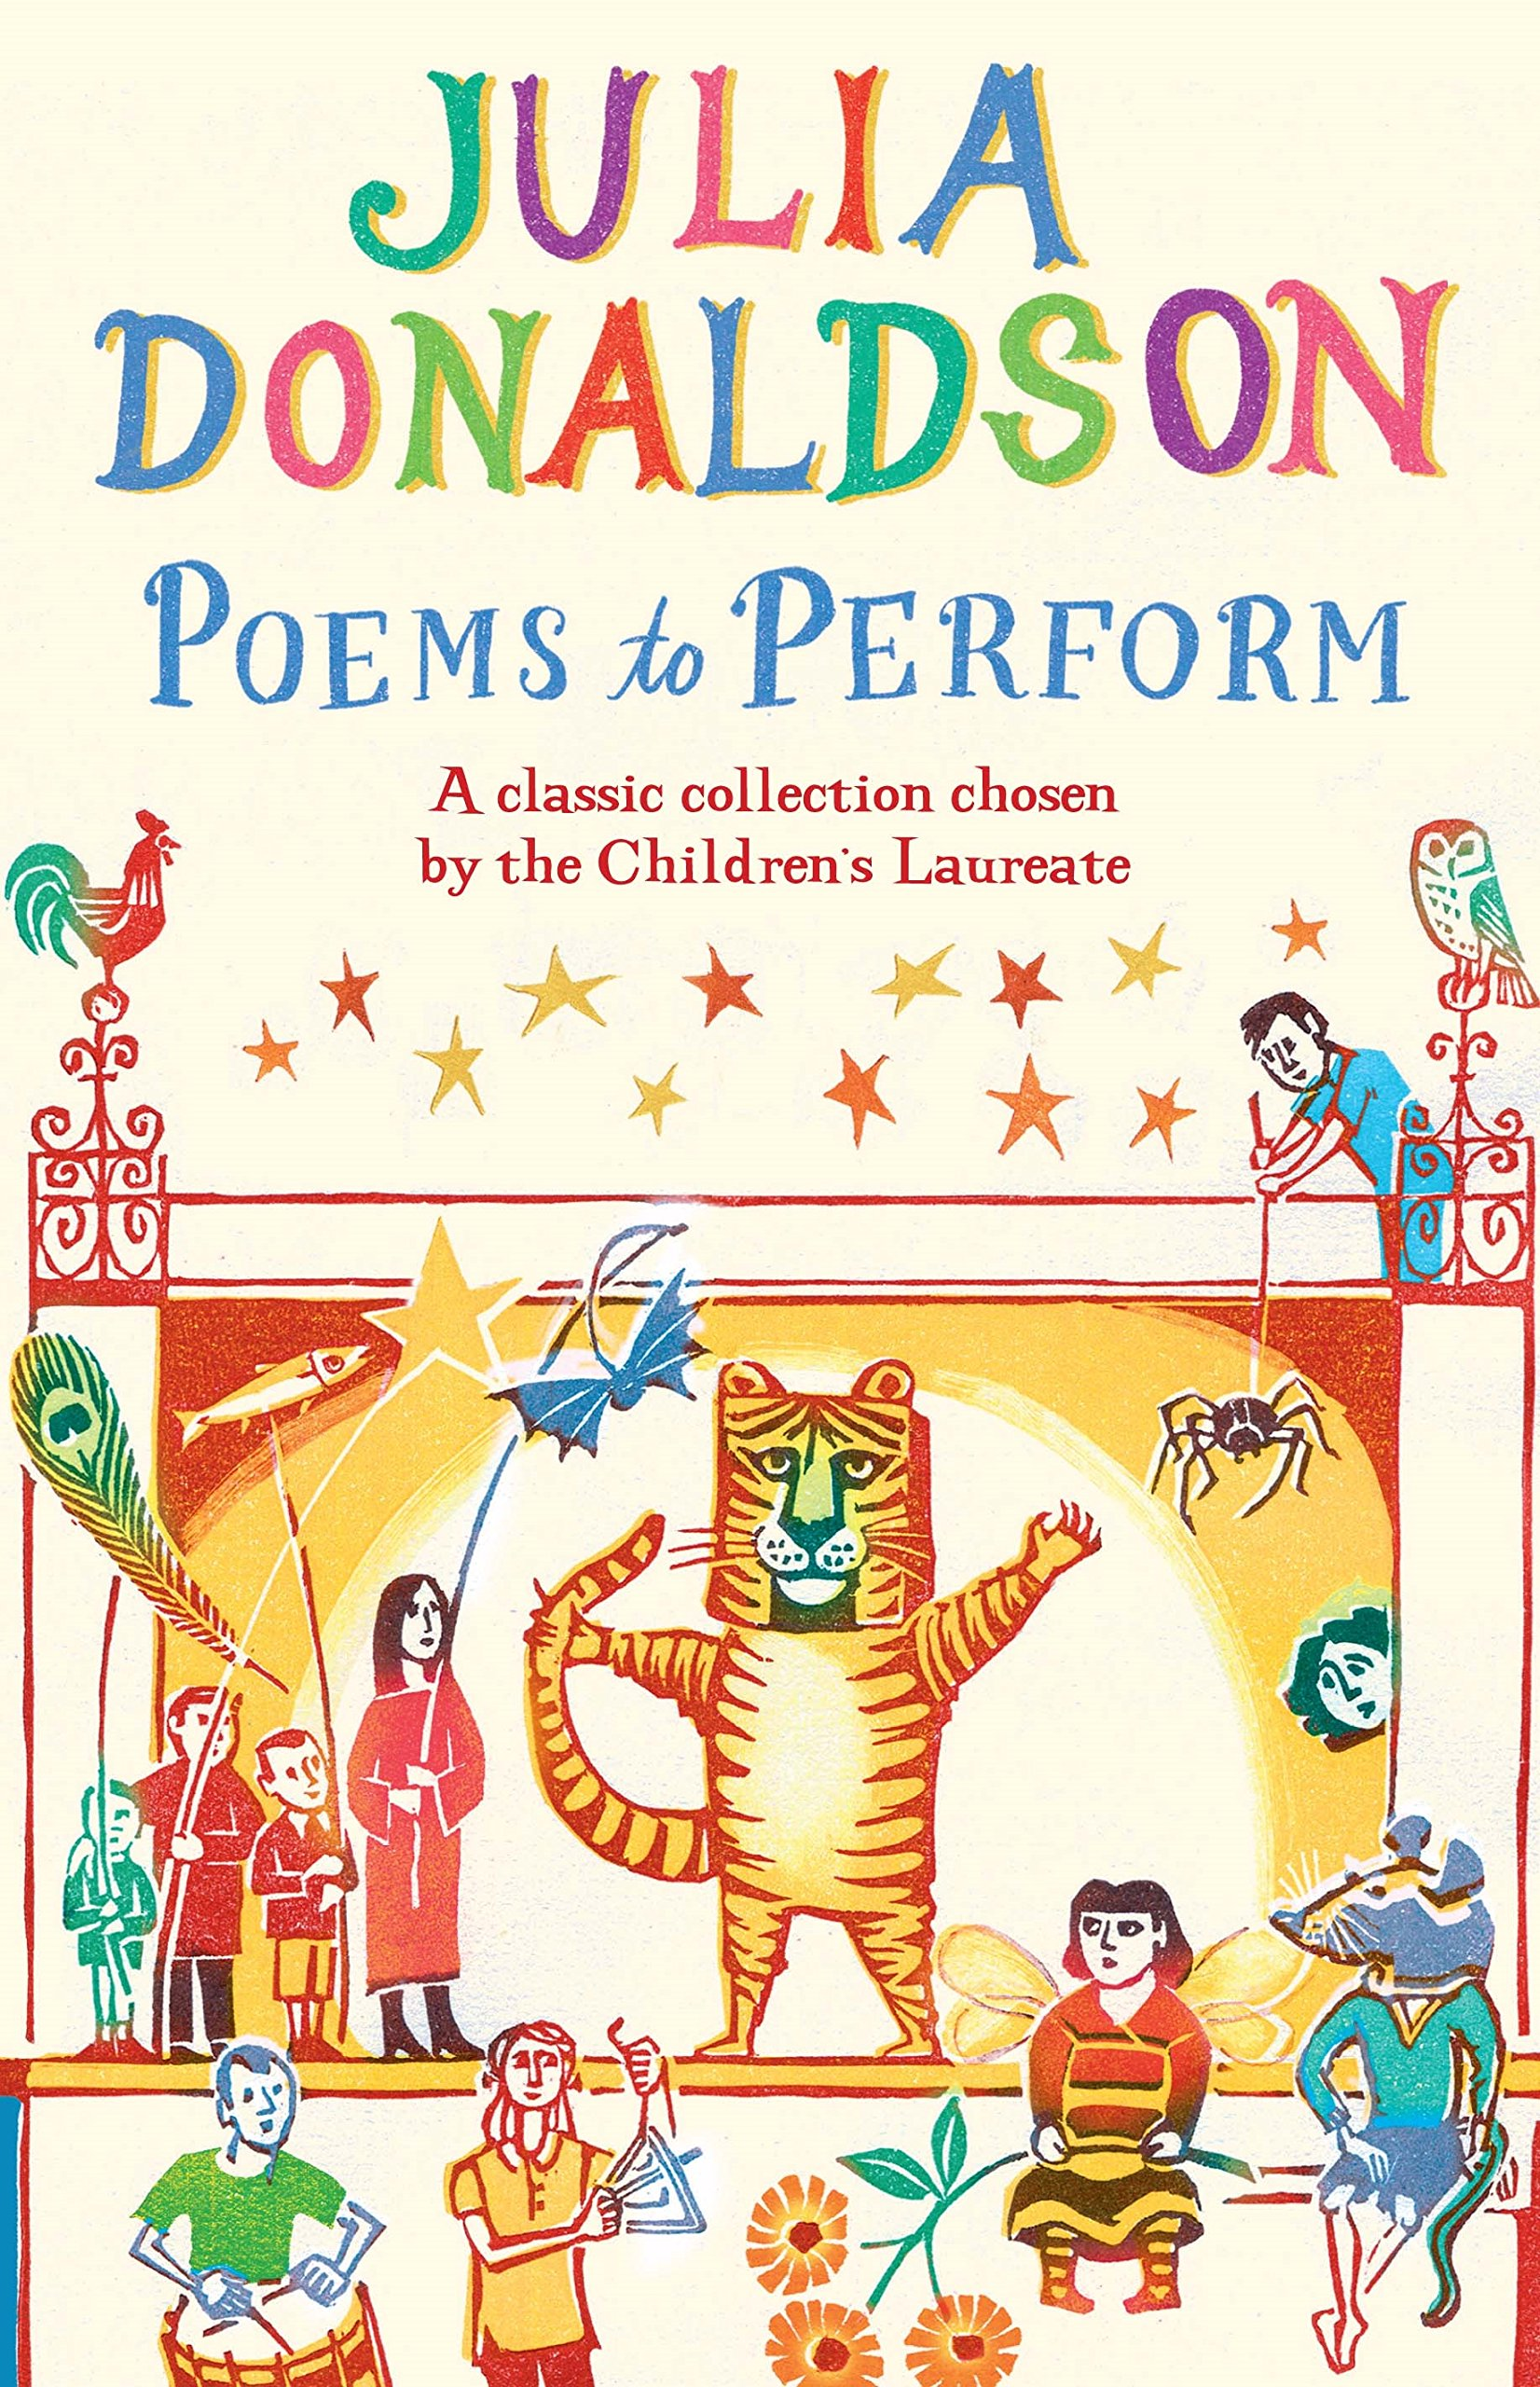 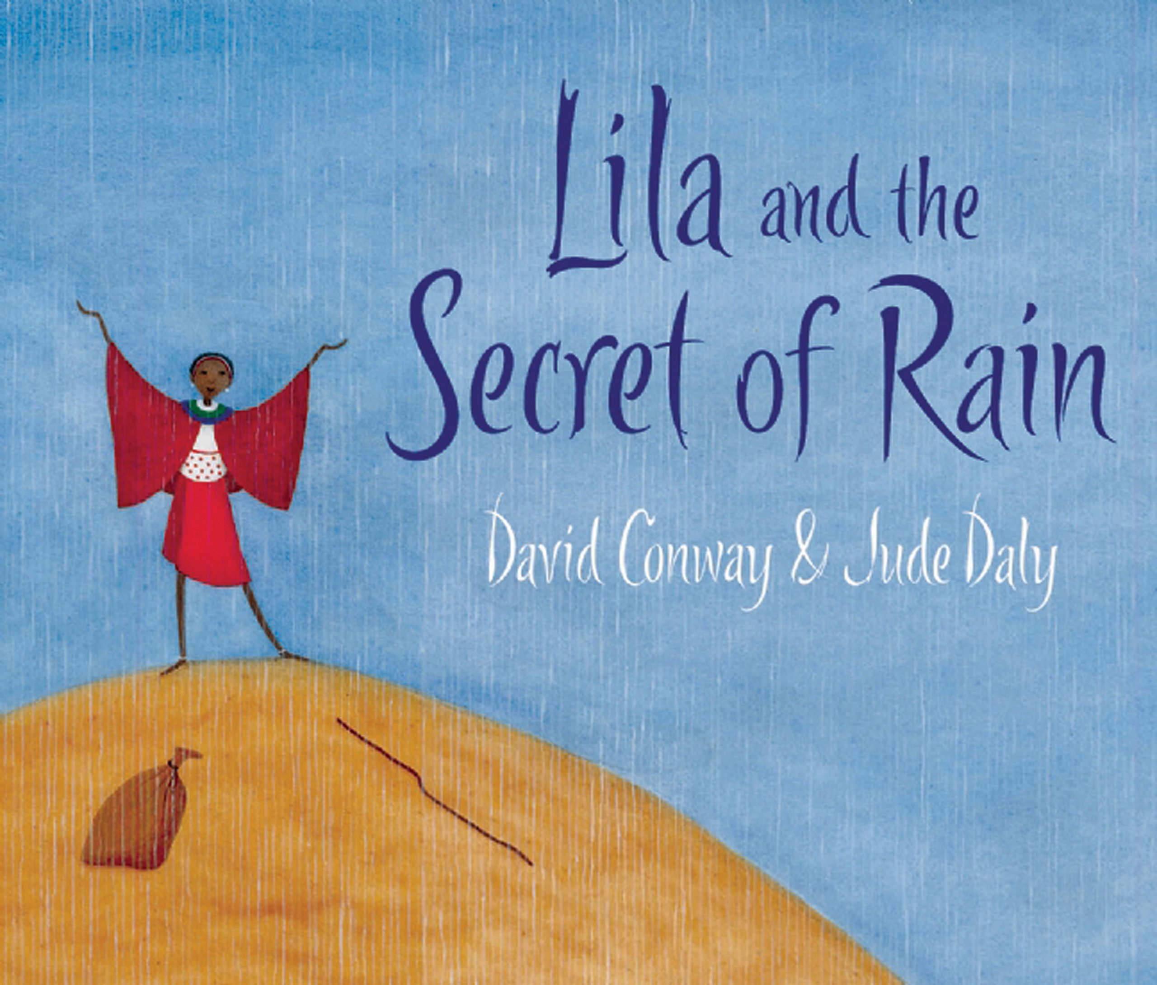 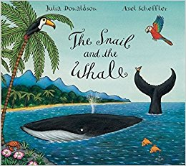

**To promote SMSC we will:**

We will reflect and learn from our thoughts.

We will respect ourselves and others.

We will cooperate and work well as a team.

**In RE we will learn:**

* Show respect for other religions and the artefacts/belief associated with them.
* Retell stories from Hinduism showing understanding of beliefs.
* Show an awareness of where Hinduism began.
* Recall and tell story of Rama and Sita.
* Understand what Diva means e.g. light.
* Recognise Diwali as a Hindu festival which is celebrated like Easter.
* Make links to lights used in Christmas celebrations.
* Show some understanding that Christians believe Jesus is the light of the world.