At Bedford Drive Primary, children will be taught with a skills based approach in order to deepen their understanding and develop a mastery approach to their learning. There may be times where topics are used to engage the children, but we will also be looking at relevant and current events in order to get the best learning from our children.

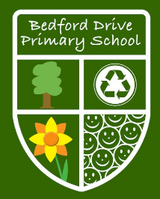

**As writers we will:**

* Organise paragraphs around a theme.
* In narratives, creates settings, characters and plot.
* Proof-read for spelling and punctuation errors.
* Write from memory simple sentence, dictated by the teacher
* Use standard English
* Use fronted adverbials
* Can choose appropriate word choices to aid cohesion and avoid repetition.
* Uses inverted commas and other punctuation to indicate direct speech

**As mathematicians we will:**

* Learn to count in 100s,1000s, 25’s, 10s, 1s
* Use place value to solve a range of problems
* Compare and order numbers
* Round numbers to estimate
* Learn to add and subtract using renaming if required
* Learn to multiply and divide using 6,7,9,11,12.
* Solve word problems using all four operations
* Learn formal compact methods for multiplication and division.

**Year 4**

**Autumn Term Skills**

**As people interested in the world we will:**

* Understand the Bible is made up of 66 books.
* Understand the basic structure of the Bible.
* Can name the Old Testament and New Testament and know what they deal with.
* Know that the Bible is the basis for Christian belief
* Explain why forgiveness is especially important to Christians because of Jesus teachings.
* Explain why forgiveness is especially important to Christians because of Jesus actions.

**As readers we will:**

* Apply a growing knowledge of root words, prefixes and suffixes.
* Read aloud and to understand the meaning of new words that are met.
* Listen to and discuss a wide range of books.
* Identifies themes and conventions in a wide range of books.
* Draw inferences such as inferring characters’ feelings, thoughts and motives from their actions and justify our ideas using evidence.
* Predict what might happen fromdetails stated and implied.
* Identify main ideas drawn from more than one paragraph and summarises these.

**As computer whizzes we will:**

* Coding: know groups of instructions are a procedure
* Predict, program, test and amend code
* Understand real-world devices are controlled using computer devices

**As geographers we will:**

* Recognise the shape of the continents
* Understand why there are differences and similarities between localities
* Identify where countries within Europe are (including Russia)
* Explore weather patterns with different parts of the world with the UK
* Use 6 figure OS local Map references of area
* Describe a route and directions using 8 compass points and linking with degrees (local area)
* Explain about key natural resources

**As historians we will:**

* Place events from historical period studied on a time line
* Use terms related to the period and begin to date events.
* Understand more complex terms e.g. BCE/AD
* Describe a study of Ancient Greek life and achievements and their influence on the western world
* Describe a study of Ancient Greek life and achievements and their influence on the western world
* Communicate own learning in an organised and structured way, using historical terminology
* Begin to evaluate the usefulness of different sources
* Understand that sources can contradict each other
* Use of text books and historical knowledge

**As artists we will:**

* Look for patterns in the work of many different artists/cultures
* Make a textured tile with card using wool (weaving)
* Create a preformed shape using newspaper and mod-rock

**As designers we will:**

* Create designs using exploded diagrams.
* Consider how existing products and his/her own finished products might be improved and how well they meet the needs of the intended user.
* Use techniques which require more accuracy to cut, shape, join and finish his/her work e.g. Cutting internal shapes, slots in frameworks.
* Apply techniques he/she has learnt to strengthen structures and explore his/her own ideas.

**As musicians we will:**

* Listen and appraise – using key vocabulary
* Compose and perform, including improvisation
* Sing in a group / ensemble
* Develop an understanding of formal notation

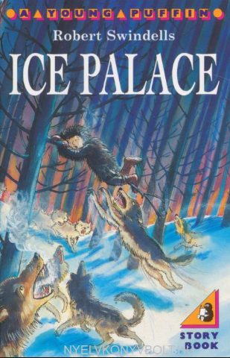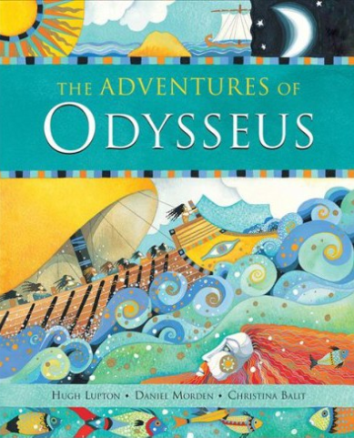

**As athletes we will**

* Participate in team games.
* Develop simple tactics for attacking and defending.
* Play competitive games, modified where appropriate.
* Succeed and excel (in competitive sport) and other physically demanding activities.
* Compete in a range of increasingly challenging situations.

**Books we will use to engage our learners:**

**As scientists we will:**

* Identify and group animals with and without skeletons and observing and comparing their movement.
* Compare and contrast the diets of different animals and decide on ways of grouping them according to what they eat. Compare the teeth of carnivores and herbivores
* Explore the effect of temperature on different substances such as chocolate, butter and cream.
* Investigate the effect of temperature on washing drying or snowmen melting
* Observe water as a solid, a liquid and a gas and should note the changes to water when it is heated or cooled.
* Observe and record evaporation over a period of time, such as a puddle in the playground or washing drying on a washing line
* Asking relevant questions and using different types of scientific enquiries to answer them.
* Setting up simple practical enquiries, comparative and fair tests.
* Making systematic and careful observations and, were appropriate taking accurate measurements using standard units, using a range of equipment, thermometers and data loggers.

**To promote SMSC we will:**

* Explore values and beliefs
* Know what makes them and others happy
* Reflect on our lives
* Respect others